Application pack for the post of
Head of Mathematics MYP/DP
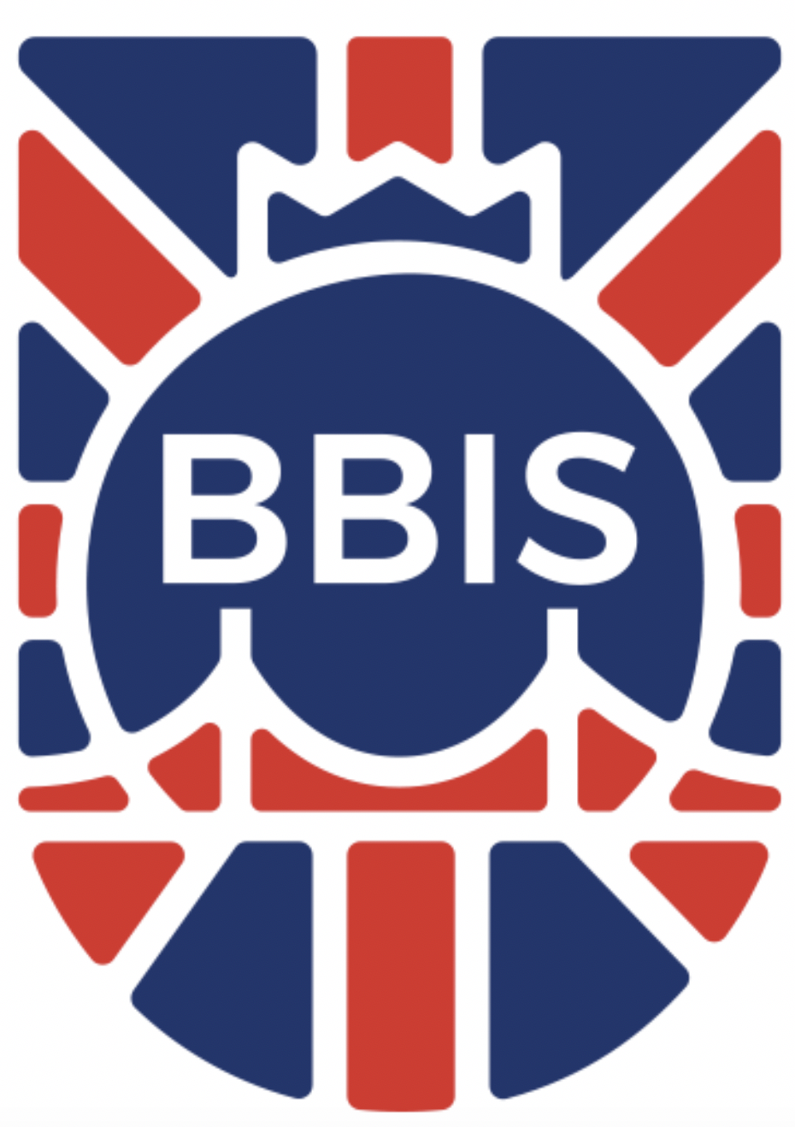
Budapest British International School
Hungary

“At BBIS we enable pupils to achieve academic excellence and more than they think they can in a small caring school. We nurture creative and responsible global citizens, with mindsets for success”

INTRODUCTION
Budapest British International School seeks an innovative, positive and inspirational Head of Mathematics and MYP/DP teacher, to be part of our growing and happy school. BBIS aspires to be a Google school, STEAM school and an Apple school, leading the way in offering pupils the best of digital education.

Budapest British International School is a COBIS school. BBIS is unique in international schools, selecting on entry and limiting class sizes to 16 in the Primary school and 18 in the Senior School. BBIS will never have more than two classes in each year group, and prides itself at offering cutting edge teaching, academic programs and preparing its pupils for international success in the 21st century.
Our School:

BBIS offers excellence in a smaller more personal educational environment, leading the way in a new approach to international education. The founder of BBIS envisaged a unique school with members drawn from the local and international community sharing a high quality academic and personal education in beautiful surroundings.

As student numbers go from strength to strength; an exceptionally exciting period of growth and development lies ahead. In the next few years, we will expand to capacity (circa 380 students), develop our facilities accordingly (including a new senior school) and undertake a successful transition to becoming an authorized IB Middle Years Programme (MYP) school, and eventually an IB Diploma School. As such, now is the time to join BBIS and be part of something uniquely challenging and rewarding.

Our Mission:

“At BBIS we enable pupils to achieve academic excellence and more than they think they can in a small caring school; We nurture creative and global citizens, with mindsets for success”

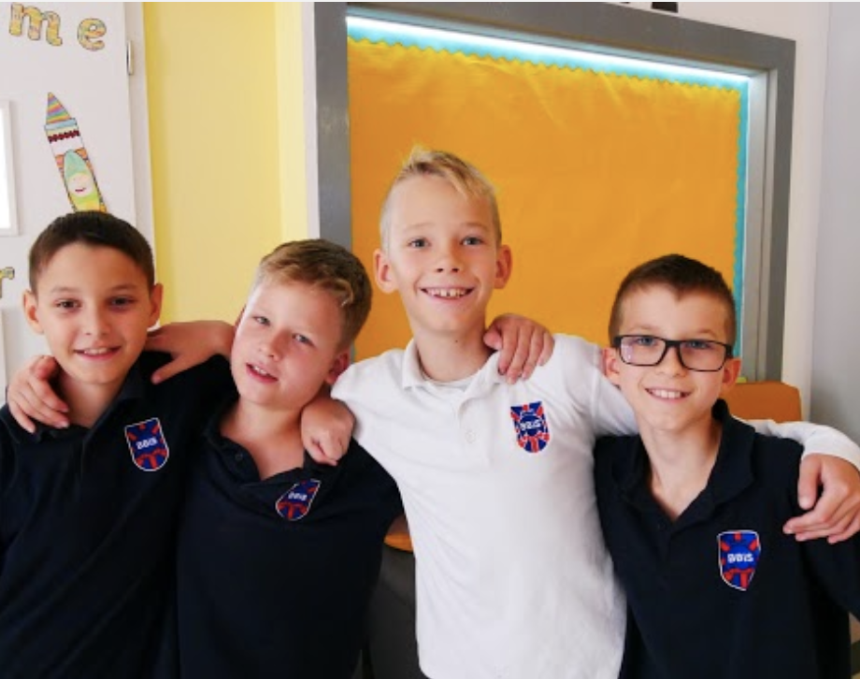

LEARNING AT BBIS
BBIS aims to offer a truly unique international education. Our COBIS accredited school combines the traditional feeling of a small community school, with a dynamic and modern teaching and learning environment, and an ambitious and globally minded school community.
BBIS is currently mid phase of its MYP accreditation, and has applied for IB Diploma candidacy, with the candidacy phase due to start by the end of December 2019. Pupils are selected on entry and the assessment system is an integral part of the development of the school’s IT.
Classes are small and BBIS is committed to continual professional development of all staff to achieve more than they think they can. Staff are committed to being life long learners and form dedicated professional learning communities.

LOCATION

Hungary is a beautiful country which is both safe and nurturing. A unique feature of our school is its idyllic setting in the Buda hills residential area. Since emerging from behind the Iron Curtain, Budapest has become one of Europe's best-loved destinations, with good reason. The city has been called the 'Paris of the East', and romance is all around.

Through the middle runs the Danube, lights from illuminated bridges dancing at its surface. The hills of Buda rear from the western bank, home to the cobbled medieval quarter with its grand palace and multi-coloured Matthias Church. Across the river sits the magnificent domed Parliament building, and around it the elegant 19th-century mansions that today contain the shops, bars and cafés that give Pest its buzz.

You can browse a colourful market for wooden crafts in the morning, soak in a thermal bath after lunch and head for the crumbling courtyard of an atmospheric 'ruin pub' after dark. Every type of cuisine is represented in the restaurants, there’s accommodation to suit any pocket, and the sights are rarely more than a short walk away. Its the perfect place to explore Central and Eastern Europe and the array of fantastic restaurants and bars, and exceptionally good prices makes it a great city to live in for quality of ife!
There's a lot more to Hungarian food than goulash, and it remains one of the most sophisticated styles of cooking in
Eastern and Central Europe. Magyars may exaggerate when they say that there are three essential world cuisines – French, Chinese and their own. But Budapest’s reputation as a food capital dates largely from the late 19th and the first half of the 20th century and, despite a fallow period under communism, the city is once again commanding attention. So, too, are Hungary's excellent wines – from Eger's complex reds and Somló’s flinty whites to honey
-sweet Tokaj.

Follow this link to the Lonely Planet Guide for Budapest to discover more!
https://www.lonelyplanet.com/hungary/budapest

BBIS Head of Mathematics (MYP/DP)

Job Description

Job Summary
We are searching for an exceptional educator to lead our Mathematics Department. A willingness and ability to collaborate with high-functioning peers, a genuine love for working with students and absolute commitment to their all-round care are necessities at our school. Experience teaching IB Diploma/MYP Mathematics is an advantage.

Minimum Typical Education

Bachelor Degree in Education, or Bachelor Degree in any subjects with PGCE (Postgraduate Certificate of Education), or equivalent

Minimum Typical Experience

5 years of post qualification teaching experience.
An understanding of the IB and the key underpinnnings of its curriculum frameworks is essential.

Core Capabilities/ Competencies Required
Adaptability
Analysis / problem solving
Collaboration Communication Team centred Self reflection
Planning & Organising Work Translating Strategies into Plans & Actions
Valuing & Integrating Diversity
Learning Agility Leading Change Written Communication
Work Standards/ Quality Orientation
Creativity/Innovative/ takes initiative
Formal Presentation Developing Talent
Having a thorough and up-to-date knowledge of the teaching of their subject(s), their students, curriculum, pedagogy, education- related legislation and the specific teaching context. Awareness of the school’s organisation.

BBIS Classroom Teachers
The main role of the classroom teacher is to maximise student learning and development through the planning, preparation and teaching of the curriculum to meet students’ individual learning needs and achieve specific student outcomes. Teachers teach a range of student abilities and classes and are accountable for the effective delivery of their curriculum. The classroom teacher engages in critical reflection in order to improve their knowledge and skills to better engage students and improve their learning.

Classroom teachers assume roles beyond the classroom in endeavouring to maximise students’ learning. These roles include working collaboratively with colleagues and other members of the school community, and communicating with parents and care-givers. The classroom teacher’s contribution to the school goes beyond the classroom. All classroom teachers may be required to undertake other duties in addition to their teaching duties. In addition, teachers allocated teaching and learning responsibility will have specific additional accountabilities as shown below.

Main Accountabilities
Teaching and Assessment

- Building strong working relationships with students in order to make learning effective
- Planning lessons and sequences of lessons to meet students’ individual learning needs and to ensure students’ progression
- Using a range of appropriate strategies for teaching and learning and classroom management
- Using flexible groupings and structured inquiry to deliver high quality lessons in line with the IBO philosophy
- Maintaining a well organised and stimulating learning environment
- Using learning technologies to enhance learning
- Using a range of assessment and reporting methods that show student’s achievement in relation to learning outcomes

Work collaboratively with dept members to

- Set goals and targets for the department and individuals in line with whole school foci and individuals’ professional direction
- Manage, review and develop current programmes in your subject area
- Create and manage a department budget
- Manage the physical resources in the department (ensuring maintenance and replacement)
- Delegate responsibilities to dept members as required
- Use appropriate data to monitor, review and report student progress and improve learning
- Plan regular dept meetings and keep accurate minutes
- Communicate with parents and community on department related issues
- Contribute to and support whole-school events where appropriate (including, but not restricted to, Camps, Sports Days, Arts Fest, Concerts, Productions, Book Week etc)
- Promote and advocate for your subject and its needs with the WSLT (Whole School Leadership Team)
- Lead departmental colleagues in the school’s Teacher Inquiry process
- Evaluate of the impact of teaching upon learning

Wider professional roles

- Planning and engaging in professional learning activities that support school and systematic priorities
- Taking responsibility for own professional development and using the outcomes to improve teaching and students’ learning
- Making an active contribution to the policies and aspirations of the school
- Ensuring administration of classroom procedures are completed efficiently
- Collaborating with members of the school community to build a team environment that supports students’ learning
- Ensuring administration of classroom procedures is completed efficiently
- Collaborating with members of the school community to build a team environment that supports students’ learning

Other tasks
- Contributing to school-wide programme development from PYP to DP
- Promoting interdisciplinary links which will enhance ‘own’ and ‘other’ subject understanding
- Maintaining your own level of Professional Development to stay current with curricular and pedagogical developments in your subject area
- Being the pedagogical leader in your department
- Managing the performance of department members (identified at the start of each year and may include support staff)
- Attending, contributing to, and supporting Heads of Department Meetings, decisions and initiatives
- Contributing to the appointment of staff through reviewing CVs, discussion, interviewing where appropriate and making recommendations to the Head of Secondary / Principal
- Maintaining oversight of standards of achievement for your area of responsibility

Additional responsibilities may include
- Assisting with or managing an aspect of daily school management
- Assisting year level co-ordinators, curriculum co-ordinators, student management co-ordinators, Principal and Vice Principals with the performance of specific functions
- Assisting with or managing a specialist function such as sport, careers, student welfare, excursions or camps coordination
.

Notes:
Two Years Finite Contract

- All teachers are expected to contribute to the school extra curricular programme throughout the year.
- All teachers expected to participate in key school and PTA events on
identified evenings and weekends.

Salary and Conditions
Start Date: January 2020 or sooner
Contract length: Two (2) Years

Salary: competitive (based on qualifications and experience)

Medical: Comprehensive coverage for employee

Education Allowance: 100% of school fees

Travel: Passage allowance equivalent to flight from point of origin, paid at start of first contract only Relocation/Removal Allowance: None
On arrival into Budapest: Transfer from the airport to hotel / three nights hotel accommodation

Application Process

The appointment is for January 2020 or sooner if possible. The initial contract will be for a period of two years (renewable by mutual consent). The salary will be competitive and depending on qualifications and experience (this role will also include a small leadership allowance in agreement with the Principle).

Please apply to Eva Van Schalkwyk by email eva.van.schalkwyk@bbis.hu and include the content listed below (preferably in one combined PDF document with the following filename format, ‘lastname_firstname_position_submission date’; for example: ‘blog_fred_History- Teacher_24thJan2019’). Please ensure the email subject is the post being applied for:
- A completed BBIS Appliction Form
- A covering letter (max x2 sides of A4 Arial 10-12 font) explaining how you would be particularly suited to this position at BBIS. Please ensure your letter directly addresses the job description, and the essential and desirable characteristics detailed above, as well as any other aspects you consider important.
- A full Curriculum Vitae including complete employment history (x2 sides of A4 excluding references)
- Details of three referees including postal address, email address and telephone number (please ensure they know they may be contacted and will respond promptly). Note that we reserve the right to contact any of your previous employers.

The closing date for October 7th 2019. All applications will be acknowledged, and those being called for interview will be contacted with more details. Early applications are encouraged, and we reserve the right to appoint before the closing date if an exceptional candidate is found. Long-list first round interviews will take place via Skype with the relevant Head of Department and SLT member. Short-list / second round interviews will involve an interview with the Principal.

Following the interview process, we aim to make a decision quickly and inform all short-listed candidates of the outcome as soon as possible. A ‘verbal’ agreement will be expected at this stage, to be followed by contractual arrangements.

Data Protection
By submitting your personal data to BBIS as part of an application for employment, you consent to the lawful use of this data as reasonable and necessary within the normal expectations of the recruitment process. You also confirm that the personal data of any third parties (such as referees) is being provided with their consent.

Safeguarding
BBIS is fully committed to maintaining the safety and wellbeing of our students; as such, any offer of employment is subject to our safe recruitment practice which includes:

- receipt of satisfactory references (at least 2)
- identity verification (Passport or equivalent)
- satisfactory and current enhanced police check / criminal records disclosure
confirmation of qualifications (original certificates

THANK YOU FOR TAKING THE TIME TO REVIEW THESE DETAILS, AND WE LOOK FORWARD TO YOUR APPLICATION.

WE KNOW HOW MUCH TIME AND EFFORT THIS ENTAILS, AND CAN ASSURE YOU WE WILL GIVE EACH APPLICATION RECEIVED CAREFUL CONSIDERATION AND ATTENTION.

